**LARAVEL FRAMEWORK**

**MVC ARCHITECTURE**

<https://www.guru99.com/mvc-tutorial.html>

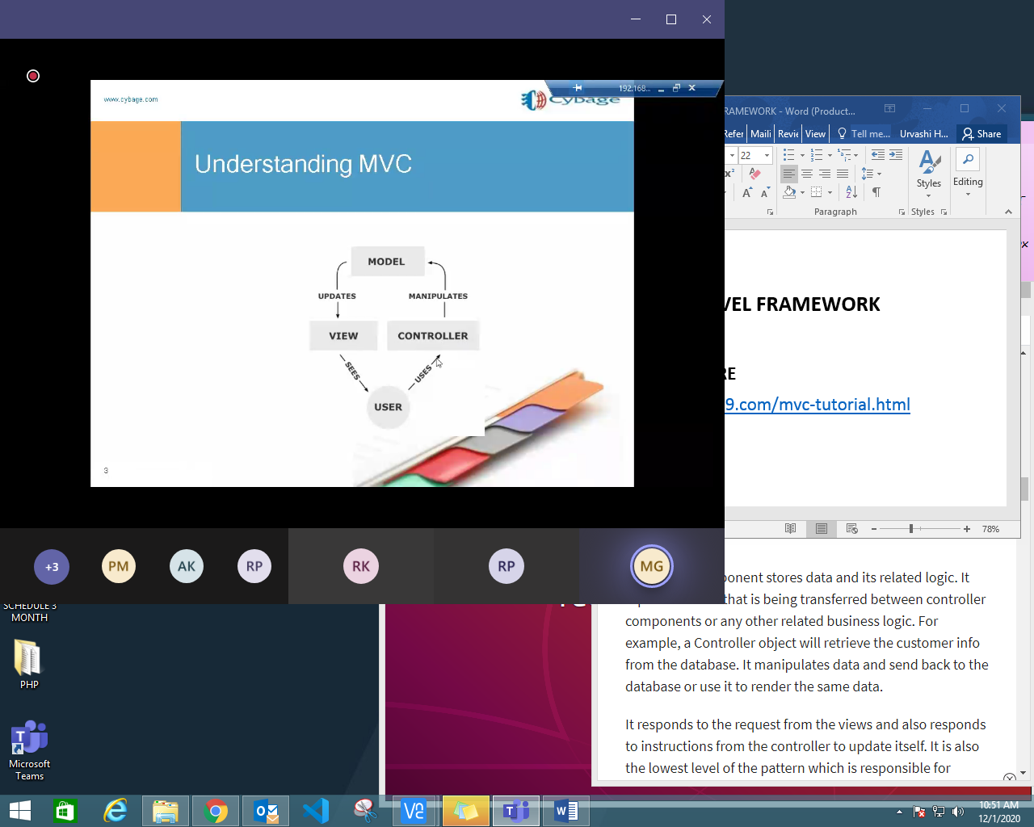

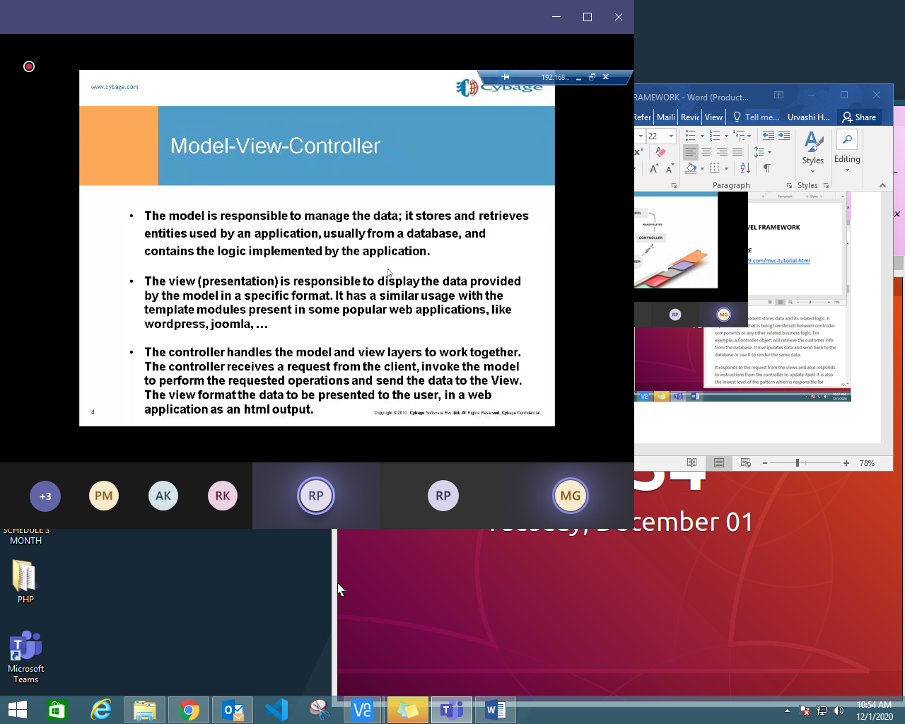

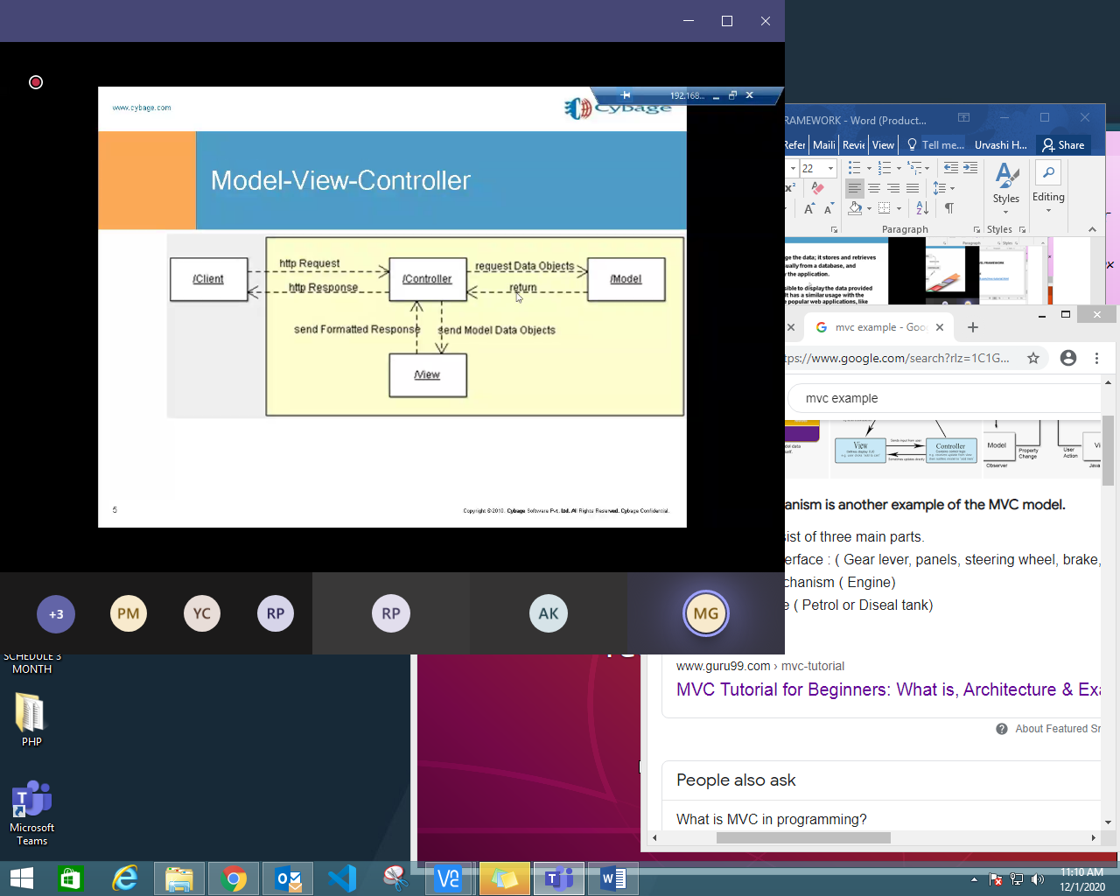

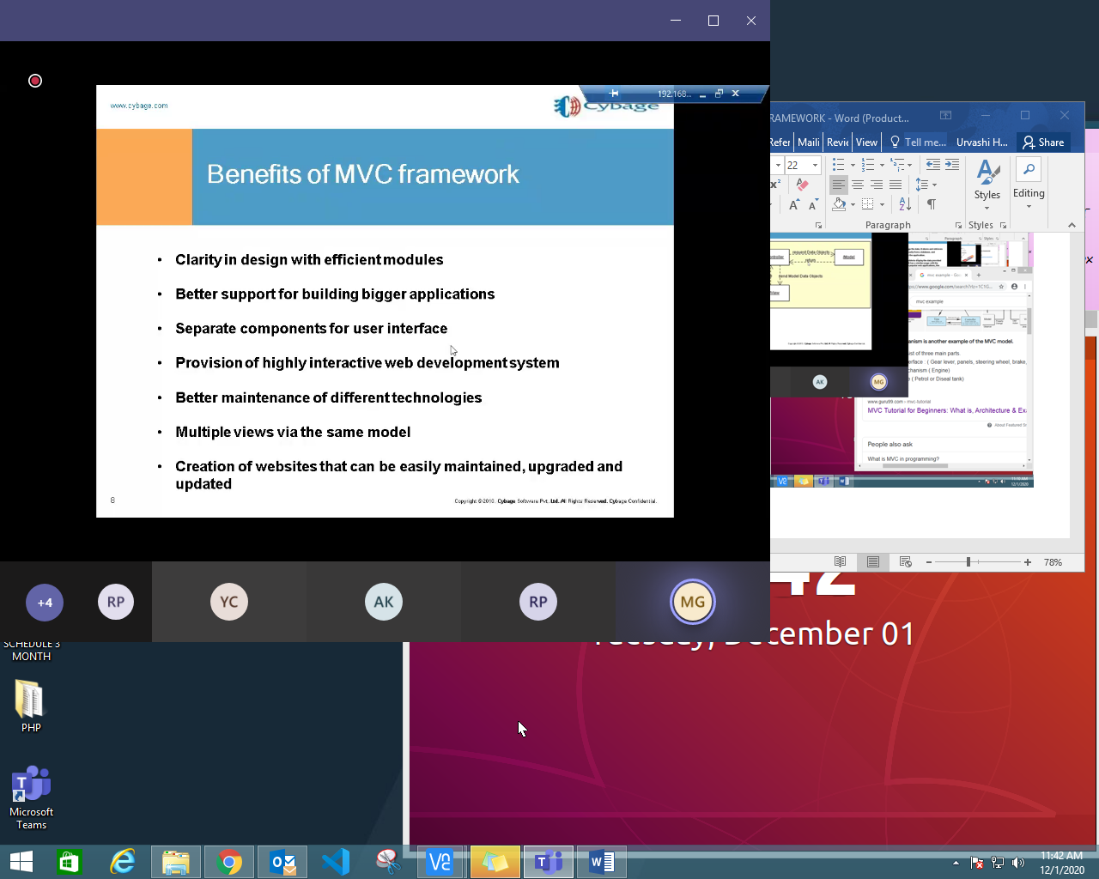

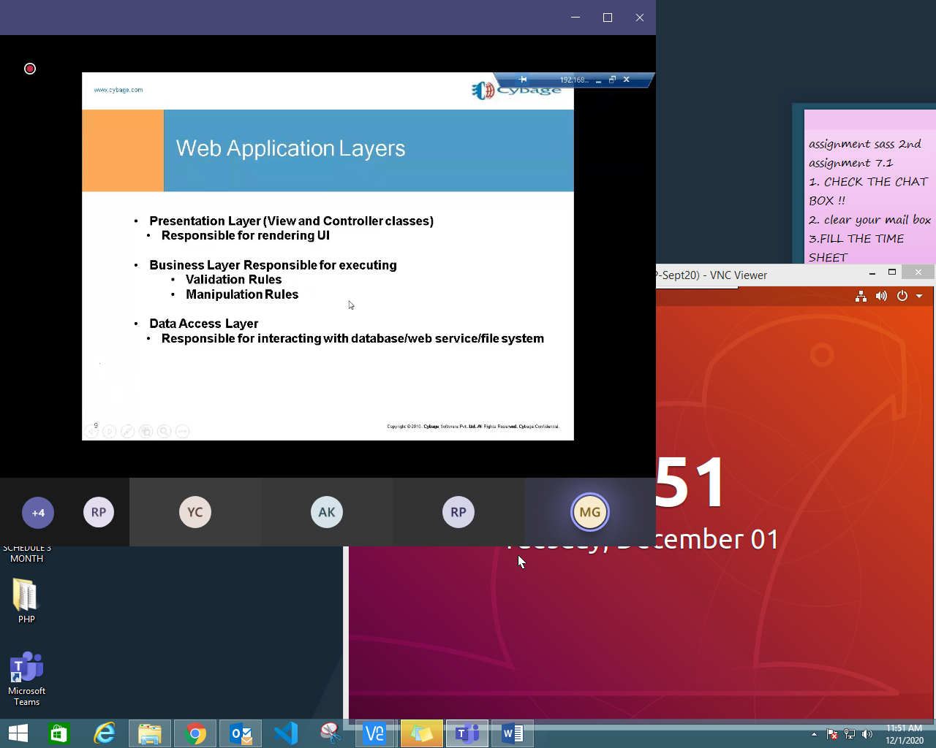

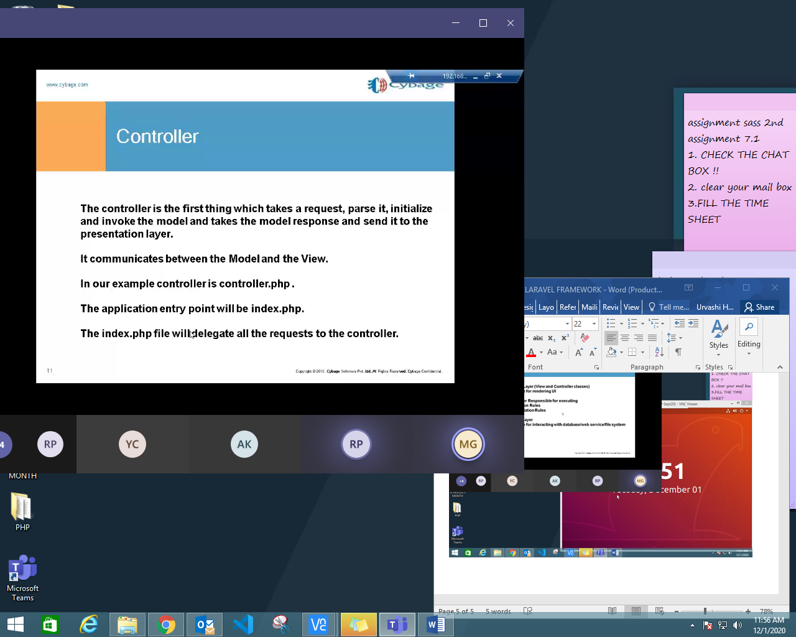

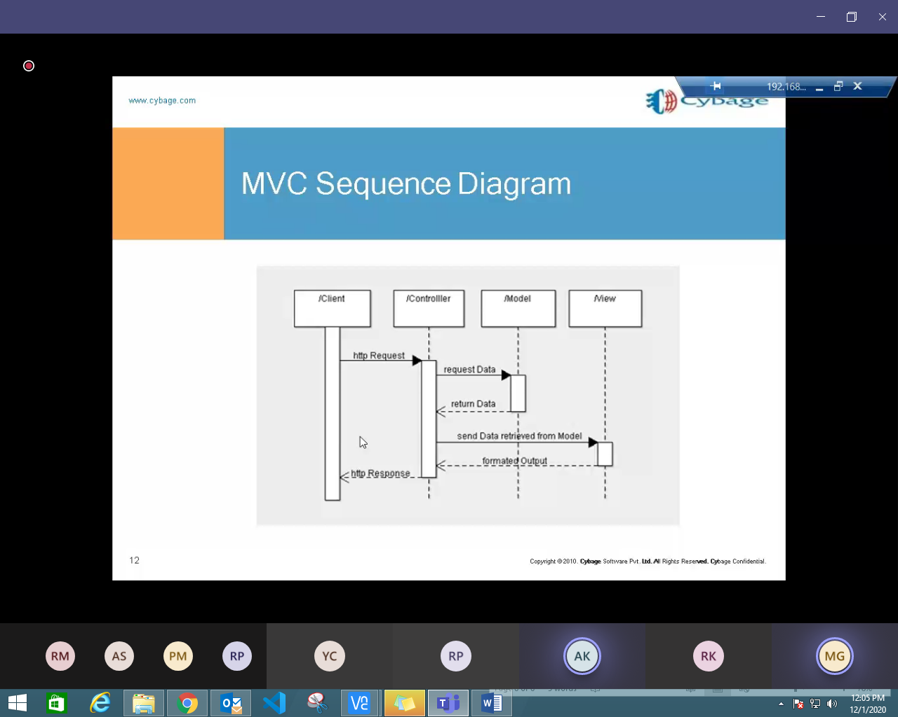

**@csrf -**

[**https://www.geeksforgeeks.org/laravel-csrf-protection/**](https://www.geeksforgeeks.org/laravel-csrf-protection/)